School of Research Science
Year 3
Autumn 1 2020 - 2021
Subject | Week 1 |  | Week 2 | Week 3 |  | Week 4 | Week 5 | Week 6 |  | Week 7
Book Focus | Sizo  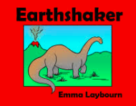 |  |  |  |  | The big little book of dinosaurs  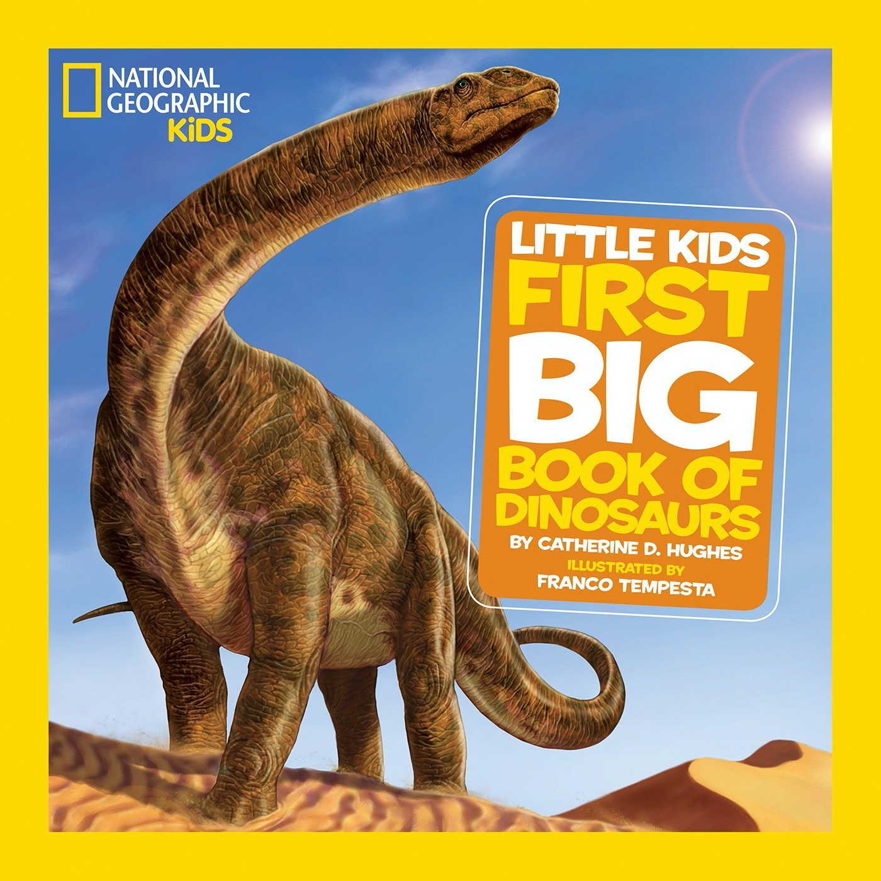
Grammar | Adjectives |  | Conjunctions | Pronouns |  | Pronouns | Subordinate conjunctions | Conjunction |  | ??
Phonics | Set 3  Multisyllabic words |  | Set 3  Multisyllabic words | Set 3  Multisyllabic words  comprehension  ICT Link:  weebly |  | Multisyllabic words  comprehension  ICT Link:  weebly | Multisyllabic words  comprehension  ICT Link:  weebly | Multisyllabic words  comprehension  ICT Link:  weebly |  | Multisyllabic words  comprehension  ICT Link:  weebly
English | Narrative  Introduction to story writing |  | Narrative  Learning the story through Talk for Writing | Narrative  Draft - redrafting the story as episodes |  | Non- Chronological reports  Comparing non-fiction text | Non- Chronological reports  Gathering information | Non- Chronological reports  Writing a report |  | Writing week  independently writing own story linked to previous learning
Lesson Planning for Remote Learning | L1: All about me  Focus:  L2: Cold Task. To write own story about a very big dinosaur. Teacher to produce video to support with ideas  .  Focus: Understanding of story writing for assessment  L3: To read and understand the story of Sizo on book creator, watch video of story being read.  Focus: Speaking and Listening and comprehension  L4: To act out part of the Sizo story and record using Ipad.  Focus: Drama skills  L5: (optional) To build a bank of vocabulary for the Sizo topic.  Focus: Adjectives  ICT Link: Become familiar with iPad and Book Creator. Take and upload digital photos.  Assessment - judge videos against speaking and listening objectives.  Assessment: Spelling Test / Assessment of Cold Task  Bespoke KO for novel created  Teacher complete mark up/annotation on work submitted on showbie with accompanying voice feedback to guide improvements. |  | L1: To create a story map using key note and upload. Students to watch video from teacher to record key ideas in images to help them retell.  Focus: To understand main ideas for story retelling  L2: To create a story map using key note and upload. Students to watch video from teacher to record key ideas in images to help them retell.  Focus: To understand main ideas for story retelling  L3: Students to describe Sizo using a mixture of sentences or voice notes, focus on adjectives and inference.  Focus: Writing - Adjectives  L4: To describe a new fictional character using Sizo as a guide. How can we develop our character  Focus: Using a known character to create a new one  ICT Link: https://www.youtube.com/watch?v=EKuhucI19_k&list=PLiMIqKsOLxPwC2xrxB9ocZRu1tS-xeB1a  Book creator of story for children to read (HA/MA) or listen to (LA)  Photos and videos to be taken of children using T4W actions and orally retelling the story.  Assessment: Spelling Test / Assessment of written work  Teacher complete mark up/annotation on work submitted on showbie with accompanying voice feedback to guide improvements. | L1: To use boxed up plan off Sizo to create a new plan for own story. Teacher to produce a video to guide children on main ideas  Focus: To identify the main ideas in a story  L2: To write the beginning and build up of a story using the boxed up plan. Focus: Punctuation and sentence structure using the story map.  L3: To write the problem of a story using the boxed up plan. Focus: Punctuation and sentence structure using the story map.  L4: To write the resolution and ending using the boxed up plan  Focus: Punctuation and sentence structure using the story map.  ICT Link:  Videos of children’s own T4W actions accessible - use this to support with story writing.  Children to send in writing each day on Showbie for teacher to feedback  Knowledge Organiser to include key characteristics of main characters and vocab describing the setting.  Pre recorded teacher video with explanation and modelling of turning a plan into a story  Assessment: Spelling Test / Assessment of written work  Teacher complete mark up/annotation on work submitted on showbie with accompanying voice feedback to guide improvements. |  | L1: Cold Task: Children to write a non chron report about a dinosaur. Upload on Showbie  L2: Features of a non chron report - what do we know already  L3: Immersion in Non chron reports - compare and contrast  L4: Reconstruct a non chron report from what we know now  ICT Link: Videos to support learning - teacher modelling  Key note examples of Non chron reports with voice explanations from teacher  Assessment: Spelling Test / Assessment of written work  Children to upload videos of their key learning about Non chron reports using clips | L1: Research class dinosaur - teacher modelled - children research own dinosaur  L2: What key information do we want to include in our report - construct plan  L3: Write introduction of non chron report - what do we need to include - use good models as an example  L4: Write first paragraph of report - features of a paragraph - what do we need to include  ICT Link: Videos to support learning - teacher modelling  Videos of different dinosaurs to generate ideas  Assessment: Spelling Test / Assessment of written work  Pre recorded teacher video with explanation and modelling of turning a pla into a report  Teacher complete mark up/annotation on work submitted on showbie with accompanying voice feedback to guide improvements. | L1: Write second paragraph of report - features of a paragraph - what do we need to include  L2: Write third paragraph of report - features of a paragraph - what do we need to include  L3: Write conclusion -recap main ideas.  L4: Edit and improve report. Have you included all the key features?  ICT Link: Videos to support learning - teacher modelling  Assessment: Spelling Test / Assessment of written work  Teacher feedback/annotation on work submitted on showbie with accompanying voice feedback to guide improvements. |  | L1: Children to plan own version of Sizo story  L2: Children to independently write own Sizo story using the key learning from previous lessons  L3: Children to independently write own Sizo story using the key learning from previous lessons  L4: Children to edit and improve Sizo story based on peer feedback  ICT Link: Videos to support learning - teacher modelling  Assessment: Spelling Test / Assessment of written work
Maths | Numbers to 1000 |  | Numbers to 1000 | Addition |  | Addition | Subtraction | Subtraction |  | Addition/Subtraction  (Bar model)
Lesson Planning for Remote Learning | L1: To count in hundreds up to 1000  L2: To count in hundreds up to 1000  L3: To recognise the place value of a number  L4: To compare and order numbers  L5: Mental Maths  ICT Link:  https://www.youtube.com/watch?v=3Vje6wUxDTg  Assessment: Socrative Quiz |  | L1: To count and recall from 0 in multiples  L2: To identify and describe number patterns  L3: To identify and describe number patterns  L4: To count and recall from 0 in multiples  L5: Mental Maths  ICT Link: https://www.youtube.com/watch?v=3Vje6wUxDTg  Assessment: Socrative Quiz | L1: To find the sum of two numbers (mental strategies)  L2: To find the sum of two numbers (mental strategies)  L3: To find the sum of two number(mental strategies)  L4: To find the sum of two numbers (renaming)  L5: Mental Maths  ICT Link: https://www.youtube.com/watch?v=cfxsR6sv4jk  https://www.youtube.com/watch?v=1Nn_Hwq2Z0M  Assessment: Socrative Quiz |  | L1: To Solve number problems (renaming)  L2: To Solve number problems (renaming)  L3: To Solve number problems (renaming)  L4: To Solve number problems (renaming)  L5: Mental Maths  ICT Link: https://www.youtube.com/watch?v=mAvuom42NyY&t=174s  Assessment: Socrative Quiz | L1: To find differences between 2 numbers.  L2: To find differences between 2 numbers.mental strategies)  L3: To find differences between 2 numbers.mental strategies)  L4: To find differences between 2 numbers.mental strategies)  L5: Mental Maths  ICT Link:  https://www.youtube.com/watch?v=OSYXMxtzGbA&t=16s  Assessment: Socrative Quiz | L1: To Solve number problems (renaming)  L2: To Solve number problems (renaming)  L3: To Solve number problems (renaming)  L4: To Solve number problems (renaming)  L5: Mental Maths  ICT Link: https://www.youtube.com/watch?v=Y6M89-6106I  Assessment: Socrative Quiz |  | L1: To Solve number complex problems (Pictorial representation)  L2: To Solve number complex problems (Pictorial representation)  L3: To Solve number complex problems (Pictorial representation)  L4: To Solve number complex problems (Pictorial representation)  L5: Mental Maths  ICT Link:  https://hub.mathsnoproblem.com/teacher-guides/england/textbook-3a/chapter-02/lesson-20  Assessment: Socrative Quiz
Science  Rocks | Rocks  KWL on Rocks |  | Rocks  Natural and man-made | Rocks  Igneous rocks Sedimentary rocks |  | Rocks  Metamorphic rocks | Rocks  How fossils are made | Rocks  Understand how soil is formed |  | Rocks  Post – test  Sieving soil investigation
Lesson Planning for Remote Learning | L1: to share my knowledge about rocks.  L2: to share my knowledge about rocks.  ICT Link:  Assessment: Socrative Quiz – Pre Task |  | L1: To observe and describe different types of rocks.  L2: To investigate the properties of rocks  ICT Link: https://www.youtube.com/watch?v=EGK1KkLjdQY  Assessment: Socrative Quiz – | L1: to match rocks to their properties and suggest uses for them.  L2: To compare and group rocks based on descriptions  ICT Link: https://www.youtube.com/watch?v=EGK1KkLjdQY  Assessment: Kahoot |  | L1: to plan an investigation  L2: to investigate the hardness of rocks  ICT Link: https://www.youtube.com/watch?v=CeuYx-AbZdo  Assessment: WS assessment (journal) | L1: To explain how fossils are formed  L2: To create a fossil  ICT Link:  https://www.youtube.com/watch?v=87E8bQrX4Wg  Assessment: Socrative Quiz – | L1: To research different types of fossils  L2: To investigate what soils are made from  ICT Link: https://www.youtube.com/watch?v=x7pmsCL6Ytc  Assessment: Socrative Quiz – |  | L1: to examine a soil sample  L2:to share my new knowledge on rocks  L3: To write an experiment  ICTLink:  https://www.youtube.com/watch?v=m88XRzwtUYk  Assessment: Socrative Quiz – post task
Topic  History & Geography | Dinosaurs  Topic Entry  L1: Topic Launch - dino puzzle pieces  KWL activity about dinosaurs  L2: To explore a dino-directory  ICT Link:  https://www.nhm.ac.uk/discover/dino-directory.html |  | Dinosaurs  KQ - How were dinosaurs discovered?  To understand the process of excavating.  L1: To understand the job of an archaeologist  L2: To understand the work of Mary Anning  ICT Link: https://www.youtube.com/watch?v=qMzpA5oCGNY  https://www.youtube.com/watch?v=koota_lwU_4 | Dinosaurs  KQ -Did all dinosaurs live in the place?  To understand that dinosaur fossils can be found in every continent. Atlas work  L1: To order discoveries of dinosaur fossils  L2: To map the locations of dinosaur discoveries  ICT Link:  https://www.youtube.com/watch?v=sPFiwW8J3sY |  | Dinosaurs  KQ - What were the different types of dinosaurs and how did this affect their behaviour?  Researching a specific dinosaur  L.1:. To understand the different types of dinosaurs  L2: To create a meal plan for dinosaurs  ICT Link:  https://www.youtube.com/watch?v=G3gXWDYpLAE | Dinosaurs  KQ - What have I learnt about dinosaurs and how can I share my learning?  L1:. to plan my documentary about dinosaurs  L2;. to create a documentary about dinosaurs  ICT Link:  https://www.youtube.com/watch?v=oXwoy-Ce1ZE | Dinosaurs  KQ - What have I learnt about dinosaurs and how can I share my learning?  L1 / 2: To create a museum about dinosaurs  Cross curricular - work from Topic and Art to be shared with parents. Documentary children create to also be shared on screen.  ICT Link:  Google Expeditions - to see the inside of a museum |  | Dinosaurs  Topic exit - writing a fictional story about a group of dinosaurs trying to survive.  L1: To plan my story  L2: To write story about dinosaurs  ICT Link:  Google Expeditions - to create scene of story
Digital  and Coding | . Ipad basics - logging on |  | E-Safety | Tynker – Space Cadet |  | Tynker – Space Cadet | Tynker – Space Cadet | Tynker – Space Cadet |  | Tynker – Space Cadet  Create Book creator to share findings
Art  &  D.T | Dinosaur skin  Experiment with paint textures, using printing techniques |  |  |  |  |  | Dinosaur sculpture  Explore sculpting techniques to create a model with soft modelling clay.
P.E. | LO- To play simple team games  Relays  NC participate in team games, developing simple tactics for attacking and defending | LO- To play simple problem solving games  Know how to talk through activities in order to solve problems  NC participate in team games, developing simple tactics for attacking and defending |  | LO - To be given a problem, work as a team to choose equipment and solve the problem  (Idependent and choose own resources)  NC participate in team games, developing simple tactics for attacking and defending | TO - To play games that involve listening and communication with each other  NC participate in team games, developing simple tactics for attacking and defending |  | LO - to play simple team games that involve different roles, rules and scoring  (roles in a team)  NC participate in team games, developing simple tactics for attacking and defending |  | LO- To design their own team games including roles/rules and scoring (when appropriate)  Understand if something doesn't work they can learn from this and try another approach  NC participate in team games, developing simple tactics for attacking and defending | LO- To introduce and teach others their own game  NC participate in team games, developing simple tactics for attacking and defending
MEP and Monthly Theme  IC7 - Growing up and well-being | Setting Goals |  |  | Tolerance and Respect for Differences Including diversity

